{{#foreach doner}}
April 24, 2023

{{addr.name}}
{{addr.address}}{{addr.address2}}
{{addr.citystatezip}}

Dear {{salutation}},

Our auditor, Estep Burkey Simmons, LLC, is conducting an audit of our financial statements. For the purpose of independent verification only, please confirm the enclosed donations to the Community Foundation of Hancock County for {{year}}.

Please indicate on the next page whether this information is in agreement with your records. If it is not, please furnish any information you have that will help our auditors reconcile the difference.

After signing and dating your reply, please mail it directly to Estep Burkey Simmons, LLC, P.O. Box 42, Muncie, IN 47308-0042 in the enclosed return envelope.

Sincerely,
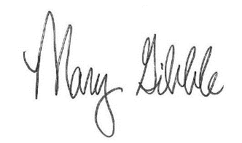
Mary Gibble
President/CEO
{{/foreach doner}}

{{#foreach doner}}
Donation Summary {{year}}

Date | Fund | Amount
{{#foreach item}}{{donation_date}} | {{funit_name}} | {{amount\# $,0.00}}{{/foreach item}}

To: Estep Burkey Simmons, LLC

The above information regarding the donations made to the Community Foundation of Hancock County agrees with my records for {{year}}, with the following exceptions (if any):

____________________________________________________________

____________________________________________________________
{{/foreach doner}}

Signature: ______________________________________

Title: ______________________________________

Date: ______________________________________

